Integrated Measurement Circuits with Low Power Consumption for ECG-Applications
H.Hauer
Fraunhofer Institute for Integrated Circuits, Erlangen, Germany, johann.hauer@iis.fraunhofer.de
E.Ryabov, S.Efimov
Vladimir State University, Russia, kanch@vpti.vladimir.su

Abstract— In medical instrumentation the demand for small battery wearable measurement and control equipment is still growing. In the field of Electrocardiography 24 hour ECG recorders for medical applications and wireless pulse per minute measurement belts with watch displays for consumer applications are on the market. Fraunhofer IIS and Vladimir State University cooperate on the development of integrated CMOS analogue digital circuits for the acquisition and measurement of electrocardiographic ECG and encephalographic EEC signals. The presentation will show an overview of the work done in this field and highlight the potential of circuit integration on an example.
The solution addresses high precision time measurement between ECG pulses. An integrated circuit was developed which measures the pulse duration with 12 bit resolution. The device includes preamplification, fully integrated band pass filter, peak detector, time measurement unit and FSK modulator for wireless transmitter. The chip consumes 200 uA at 3.3 Volt supply and occupies an area of 2.1 mm2 on a 0.35 um CMOS DPTM Process with 0.5 mm2 core area only.
Index Terms— Electrocardiography, Pulse duration, wireless transmission, low power consumption.

INTRODUCTION
Electrocardiographic signals show a typical signature with a peak for each heart beat (Fig. 1). For some heart diseases, like arrhythmics, measurement of the duration between two peaks is very important. Using clinical ECG equipment these measurements can be done by calculations on the stored data. Our aim however was to develop a low power pulse duration measurement device witch is equipped with short distance wireless transmission. So the user may wear it quite unseen on his body with a receiver in his pocket, his watch or mobile phone for outdoor activities or a computer for indoor patient monitoring.
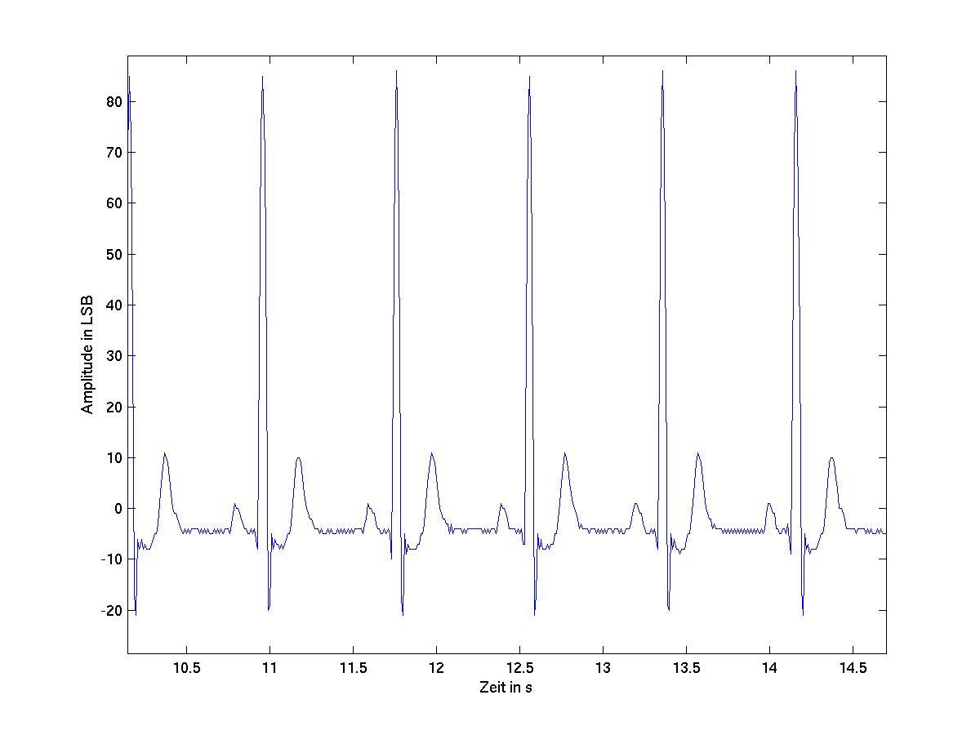
Fig. 1. Electrocardiogram
The module with the ASIC as main part will be supplied by a lithium cell with 3.3 Volt and 24 mAh. Supply current for the total measurement module should be less than 1mA to guarantee a 24 hour operation. Fig. 3 shows a block diagram of the module consisting of a master clock generator, the measurement chip and an ASK-Modulator for a 128 kHz low frequency short distance transmission.

128 kHz ClkGen
ASIC
L

N

R
Electrodes
FSK
Battery
transmission coil
Fig 2. Module Block Diagram

CHIP ARCHITECTURE
One of the main requirements was to integrate as many elements as possible in the device. A block diagram of the IC is shown in Fig 4.

Par/Ser
10
10
Preamp
2. Amp
+
N
-
Time Count
Δt
Modulator
Ser
FSK
Digital
Analogue
Band pass
Peak detect
Fig. 3 Block diagram of chip architecture

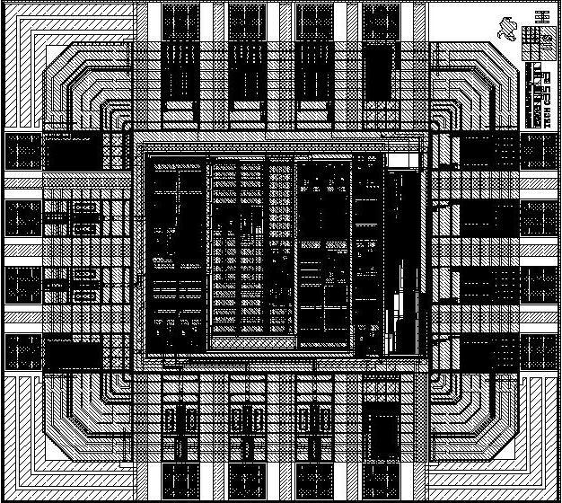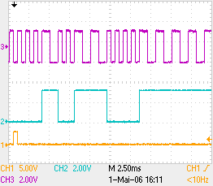
Fig. 4 Chipfoto Fig 5. Measured ECG Pulse width

CONCLUSION
A pulse measurement unit for electrocardiographic applications was developed, integrated and
evaluated. A fully integrated switched capacitor high pass filter with a 3 dB frequency of 0.8Hz @ 500 Hz clock frequency was used to remove the low frequency signals.

References
- IEC 601-2-25 “Medical electrical equipment- Particular requirements for safety of electrocardiographs”, IEC, Genf, Swiss 1993
- Paul R. Gray. “Analysis and design of analog integrated circuits” ISBN 0-471-32168-0 Copyright 2001 John Wiley & Sons, Inc.
- Philip E. Allen Douglas R. Holberg , “CMOS Analog Circuit Design.” ISBN 0-03-006587 Copyright 1987 by Sauders College Publishing, a division of Holt, Rinehart and Winston.
- Steve Winder “Filter Design” ISBN 0 75062814 6
ISBN Printed in Great Britain by Antony Rowe Ltd., Eastbourne 2001
- Nürmann Dieter “Das große Werkbuch Elektronik“ ISBN 3-77236544-2
Franzis-Verlag GmbH, München 1984

