Implementation of adaptive filters for biomedical applications
Jennifer. Baraniak (Studentin), Prof. Dr. Günther Leugering
Angewandte Mathematik II, FAU-Erlangen

Hans. Hauer, Norbert Schuhmann
Fraunhofer Institute for Integrated Circuits, Erlangen, Germany, johann.hauer@iis.fraunhofer.de

Abstract— Biomedical signal acquisition like electrocardiography ECG or electroencephalography EEC is know for quite a long time. One of the main problems in this field is still to separate the small input signals from noise and disturbances caused by the 50 Hz power supplies, high frequency interference and random body voltages. Analogue and digital low pass, high pass and band pass filters are used to remove the unwanted spectral parts. In most applications the filter bandwidth of those filters are fixed and will not adapt to changing interference patterns.
Adaptive filter techniques are required to overcome this problem. Different adaptive filter types have been analyzed. Finite Impulse Response (FIR) filters are preferred because of their better stability. An adaptive filter was implemented which suppress different known noise sources in an ECG-application. Simulations were done with MATLAB and VHDL. The filter was coded in VHDL and tested on a FPGA.
A 50 Hz interference on the ECG input signal was damped by 50 dB. The convergence time for the adaptive algorithm was less than 3 sec.
The filter implementation needed 9500 equivalent gates and worked with 7.1 uW for a filter clock speed of 1.8 KHz.

Index Terms— Biomedical signal acquisition, adaptive Filter, FIR, LMS

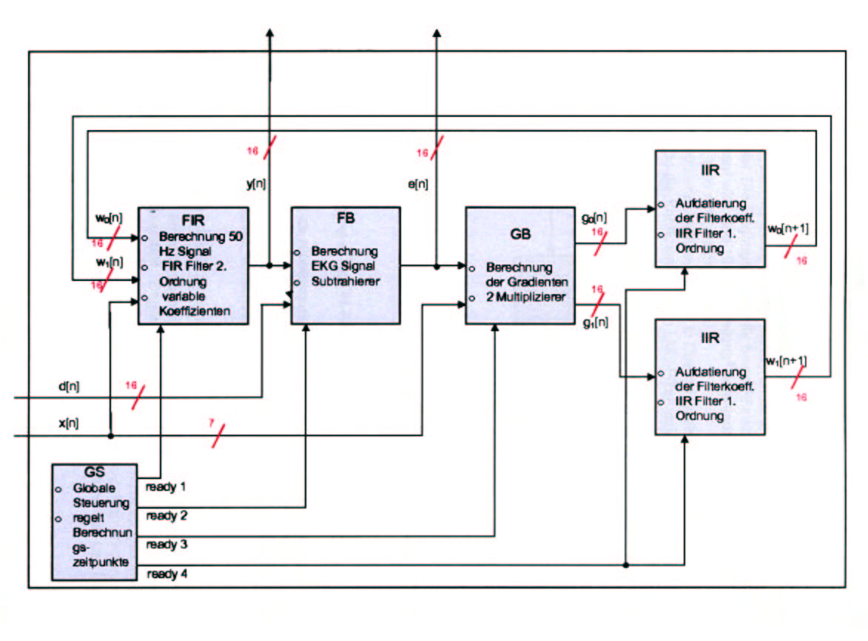
Fig. 1: Block diagram : adaptive filter implementation

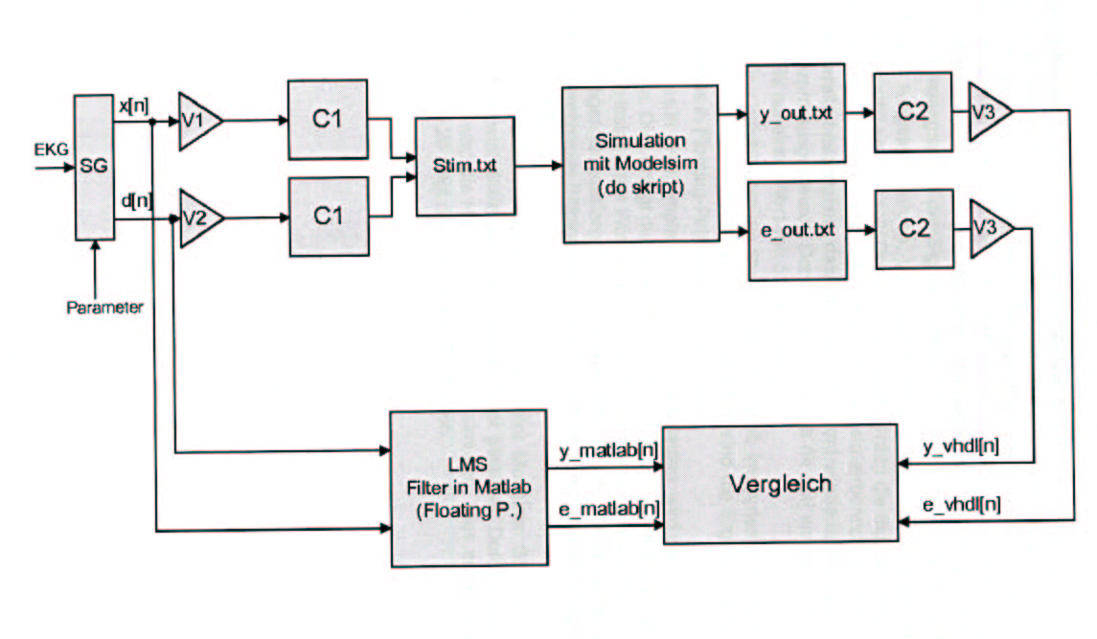
Fig. 2: MATLAB – VHDL –Cosimulation

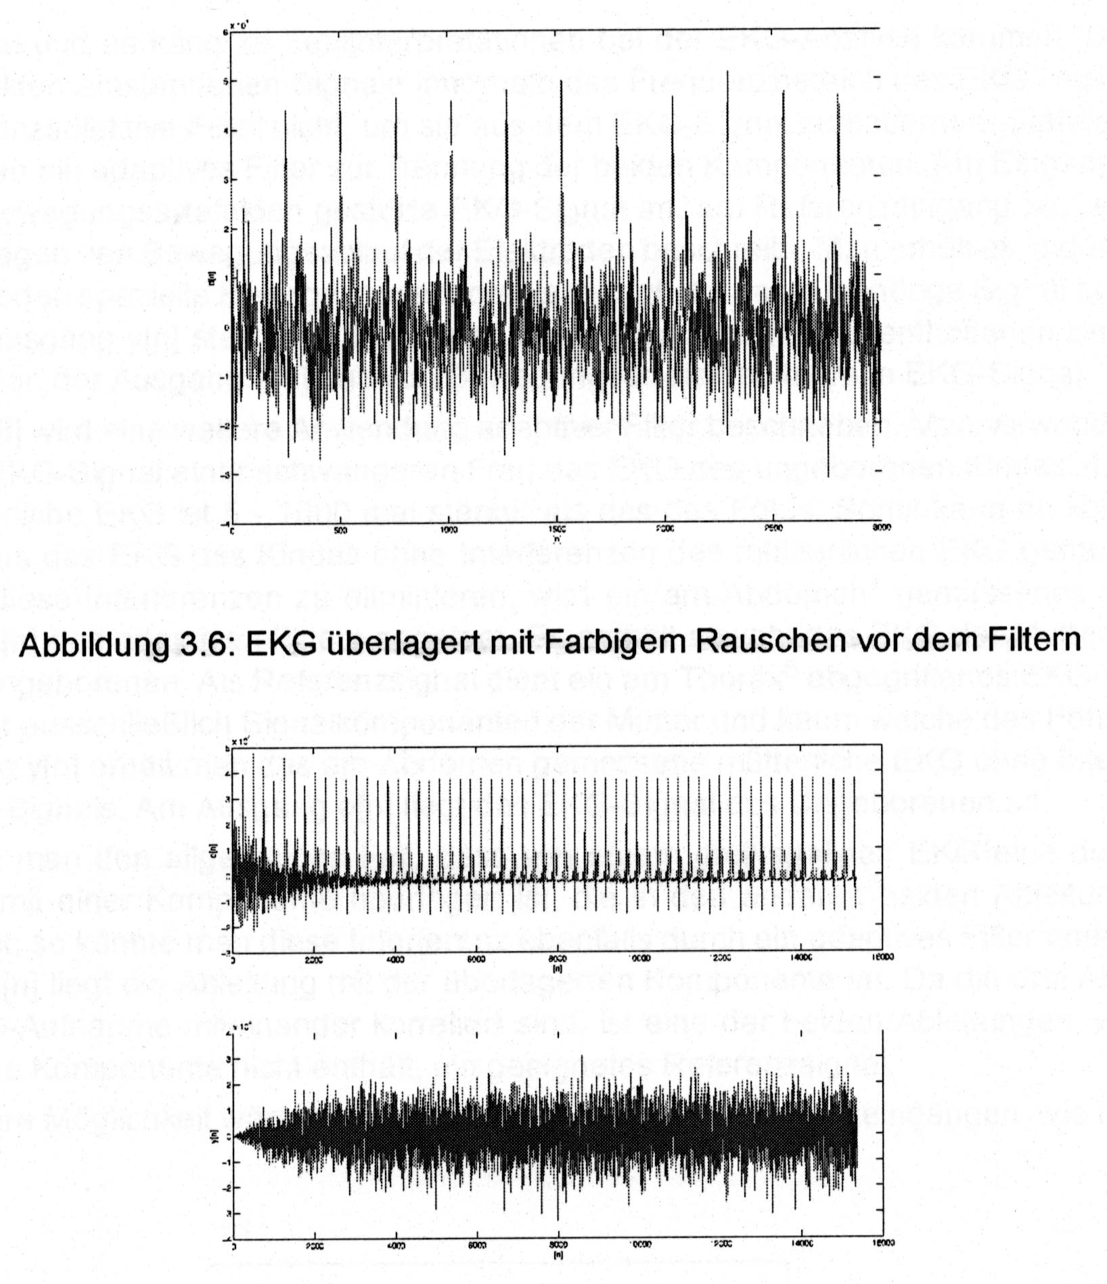
Fig. 3: Separation of noise and signal in an noisy ECG recording

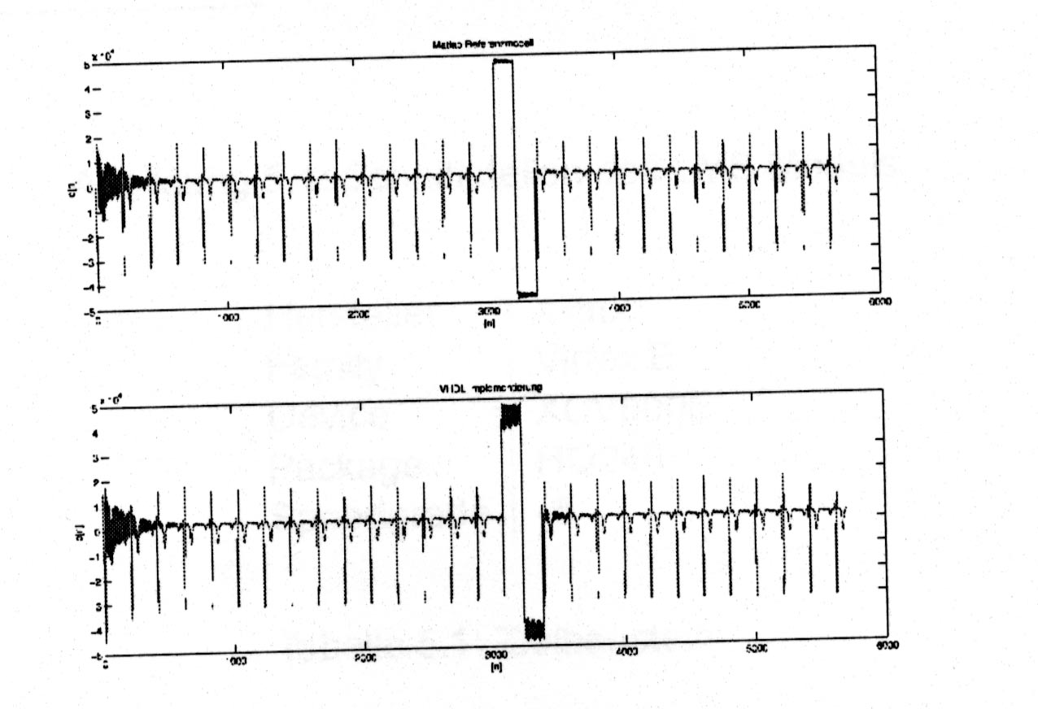
Fig. 4: Filter stability for high signal overswing

